
Business and Community Newsletter
January 2026

2026 Census of Population
Canada's next census begins February 2, 2026 in select northern and remote communities.

Census invitation letters will be delivered to dwellings in these communities in early February 2026, providing residents with the information they need to complete their census questionnaire.

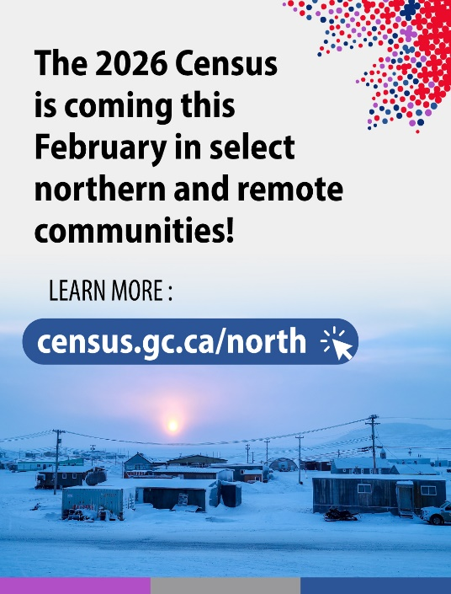
In select northern and remote communities, collection begins early to ensure access to areas that are easier to reach in winter and to count populations that typically migrate out of their communities in the spring. For the rest of Canada, collection will begin in May 2026.

How can you help us spread the word?
- Share the resources in our Community Supporter Toolkit, including posters, web images, social media content, and articles with your network.
- Engage on social media and share posts using the hashtag #2026Census.

For more information
More information about the 2026 Census can be found at www.census.gc.ca/en/north.

Features

Population projections for Census divisions and subdivisions, 2024 to 2049
Statistics Canada released new population projections by census divisions and census subdivisions. Commissioned by the Canadian Infrastructure Council to inform Canada's National Infrastructure Assessment Report 1, these projections provide impartial, evidence-based insights to all orders of government, infrastructure owners, operators and investors to improve infrastructure planning and decision-making across Canada.

Canadian Survey on Business Conditions, fourth quarter 2025
Businesses continue to anticipate a variety of obstacles over the next three months. While pressures of both cost- and labour-related obstacles continued into the fourth quarter of 2025, the proportion of businesses with a positive outlook remained comparable with previous quarters.

Study: Portrait of the South Asian populations in Canada
This is the third in a series of portraits on racialized groups in Canada, developed by Statistics Canada in support of Canada's Anti-Racism Strategy. The previous portraits are The Diversity of the Black Populations in Canada, 2021: A Sociodemographic Portrait and Portrait of the Arab Populations in Canada: Diversity and Socioeconomic Outcomes.

Census of Environment: Urban greenness, 2025
Many Canadian cities and towns were not as green in the summer of 2025 compared with one year earlier, mostly due to drought conditions across the country.

Quarterly rent statistics, second and third quarters 2025
In the third quarter of 2025, the average asking rent for a two-bedroom apartment fell year over year in 24 of the 40 census metropolitan areas in the country with available data, including Montréal (-1.0%), Toronto (-3.9%) and Vancouver (-5.9%).

Labour Force Survey, December 2025

Highlights
In December, employment was little changed (+8,200; 0.0%) and the employment rate held steady at 60.9%.
The unemployment rate rose 0.3 percentage points to 6.8%, as more people searched for work.
Employment rose among people aged 55 and older (+33,000; +0.8%), while it fell among youth aged 15 to 24 (-27,000; -1.0%).
There were more people working in health care and social assistance (+21,000; +0.7%) as well as in 'other services' such as personal and repair services (+15,000; +2.0%). At the same time, fewer people were employed in professional, scientific and technical services (-18,000; -0.9%), accommodation and food services (-12,000; -1.0%), and utilities (-5,300; -3.0%).
Every month, Statistics Canada conducts the Labour Force Survey to gather vital information about employment, unemployment, and labour market trends across the country. If you are selected, your voice matters because your response represents hundreds of Canadians. Your answers are confidential and combined with others so no one can be identified. Whether you are employed, looking for work, retired, or a student, your participation helps paint an accurate picture of Canada's economy. It helps inform decisions on job creation, education, pensions, and income support, and is used by governments, businesses, and researchers to improve the lives of Canadians. Completing the questionnaire is mandatory, but it’s also simple, secure, and a meaningful way to contribute to your community and country. Here are a few examples of how your participation in the Labour Force Survey contributes to vital insights that benefit us all.
Resources
Labour | Labour Force Survey in brief: Interactive app | Labour Statistics

Did you know… Fighting misinformation

Statistics Canada is launching a new suite of tools to help users identify and prevent the spread of misinformation when working with data. The package includes "Assessing Data in a Time of Misinformation: A Step-by-Step Guide" to help policymakers and other decision makers verify the quality, credibility and relevance of any statistic or information source. A short companion video titled "Fighting Misinformation" also demonstrates how to apply these checks in practice, from questioning suspect figures to confirming that data truly meet reliability standards. Both resources are available through the Data literacy training learning catalogue. We encourage you to explore these new materials, add them to your learning plans and share the links with your networks.


Visit StatsCAN Plus for the most recent data stories:
- Back to everything! (for most of us)
- Canadians are spending more on visits within Canada—here’s the breakdown
- New Year’s resolution: Cleaner diet. But it might be easier said than done

Podcasts



Eh Sayers Episode 28 - Screens Replaced Play, and Our Bodies Noticed

Has Canada become a sedentary nation? Health data have never been more accessible. We have smart watches to count our steps, notifications about our screen times and apps to track our daily diets. Despite the futuristic tech, researchers are growing concerned. And they’re especially concerned about young Canadians.



Eh Sayers Episode 29 - GDP Explained Without Putting You to Sleep (We Promise!)

The Gross Domestic Product (GDP) tells us about the health and size of Canada’s economy. But for those of us who don’t own or operate multi-million-dollar companies, why does it matter at all? In this episode, Amanda Sinclair, Assistant director for the National Economic Accounts at Statistics Canada, explains some surprising ways GDP can be useful and why, for certain Canadian households, the numbers don’t always seem to add up.
WEBINARS
Statistics Canada’s webinar series offers insightful, hour-long sessions on a wide range of topics—from the Census program and methodological tools for robust statistical analysis to rich data explorations in areas such as the economy, trade, health, and more. These webinars are designed to help participants discover, interpret, and apply our data with greater confidence and efficiency.

Upcoming webinars
- Health Data Webinar Series – Session 2 – Discover the Canadian Health Measures Survey (CHMS) — your gateway to unique health insights, essential data access tools, and upcoming trends shaping research and policy.
- A portrait of quality of employment in Canada: Recent results from Canadian Survey on Working Conditions – Dive into the key findings of the 2024–2025 Canadian Survey on Working Conditions, deepen your understanding of employment quality in Canada, and discover how working conditions influence workers’ well-being.



Analysis 101: Steps of the analytical process

Registration Information: English workshop dates are available in February 2026. For more information and to register for a session, please go to this link: Workshop – Analysis 101: Steps of the analytical process
Cost: $500 per participant

Introduction to Basic Statistics

Registration Information: French and English workshop dates will be available in spring 2026. For more information, please go to this link: Workshop – Introduction to Basic Statistics
Cost: $325 per participant
Early Registration (At least 3 weeks before): $300 per participant

Surveys from Start to Finish

Registration Information: French and English workshop dates are available in April 2026. For more information and to register for a session, please go to this link: Workshop – Surveys from Start to Finish
Cost: $325 per module or $975 for all 3 modules
Early Registration (At least 3 weeks before): $300 per module or $900 for all 3 modules

Turning Statistics into Stories

Registration Information: English and French workshop dates are available between March and May 2026. For more information and to register for a session, please go to this link: Workshop – Turning Statistics into Stories
Cost: $325 per participant
Early Registration (At least 3 weeks before): $300 per participant



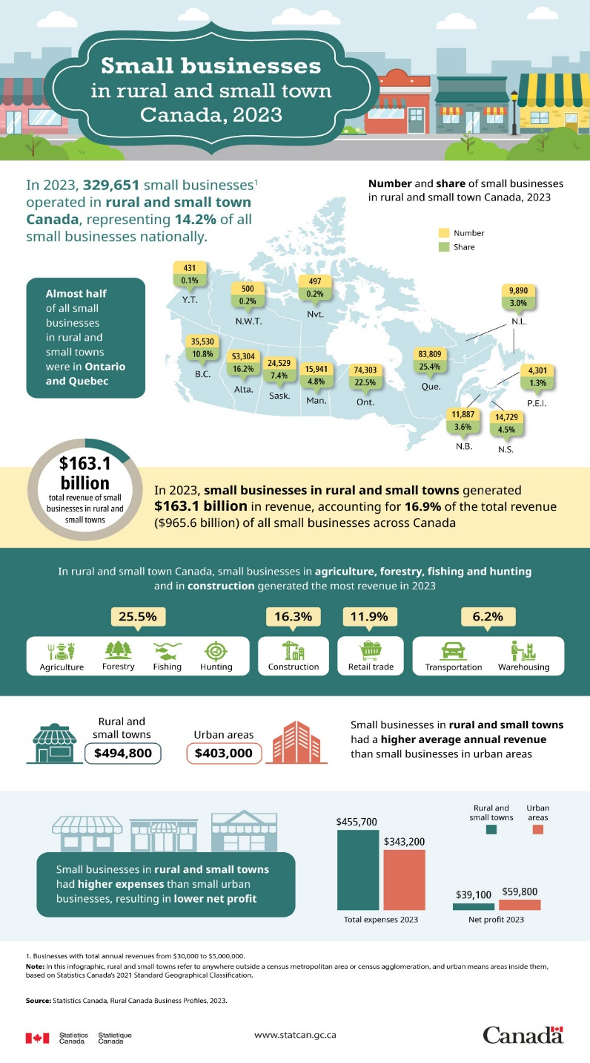
Small businesses in rural and small town Canada, 2023

This infographic from the Rural Data Lab of Statistics Canada presents a visual overview of key highlights and statistical findings from the 2023 Rural Canada Business Profiles database. The database provides financial profiles for small and medium-sized businesses in Canada with total annual revenues of $30,000 to $5,000,000 and $5,000,001 to $20,000,000, respectively. The infographic provides observations focused on small businesses in rural and small-town Canada.

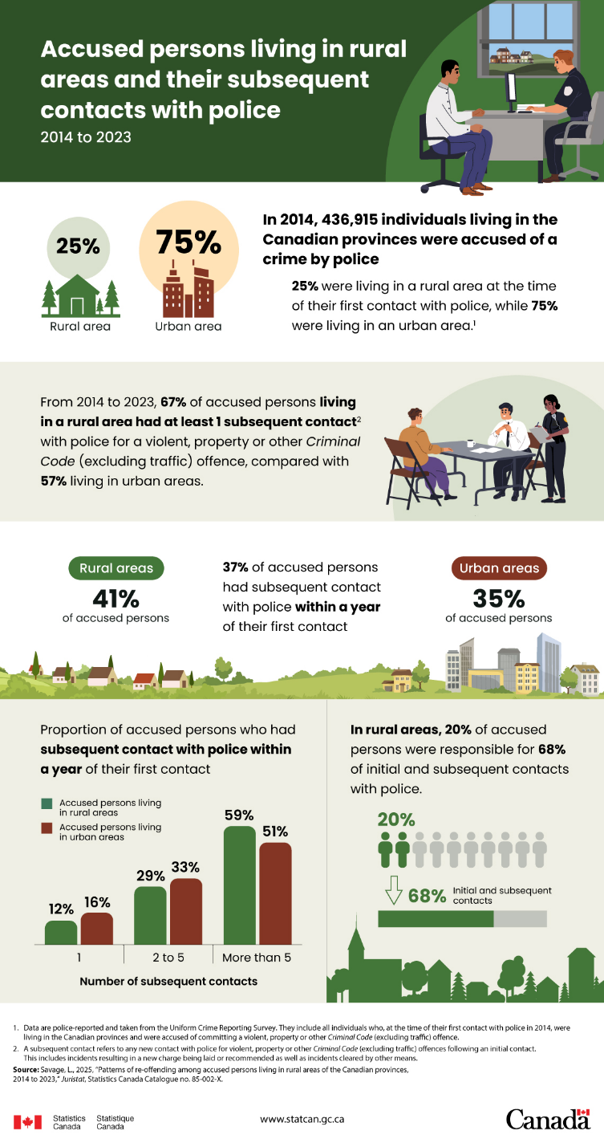
Accused persons living in rural areas and their subsequent contacts with police, 2014 to 2023

Using police-reported data from the Uniform Crime Reporting Survey, this infographic presents data on subsequent contacts with police over a nine-year period for individuals living in rural areas of the Canadian provinces who were accused of a crime in 2014.

